This site was not really finalized (working yet), but I like the template and the layout. I would love to keep the look and feel as much as possible in the new site.

The Logo, at the top left is the only thing that’s really mine and I’ll keep. All current images are just sample, and I’ll replace them with my own. After the a working we have a working foundation site.

Here are some screen shots of the current site, to give an idea of what it looks like.

As the name implies, this e-commerce site will be selling some of the most popular prime healthy teas from around the world.

Based on recommendation from Claude we’ll use the following:

* Next.js
* Medusa

**Home pages**

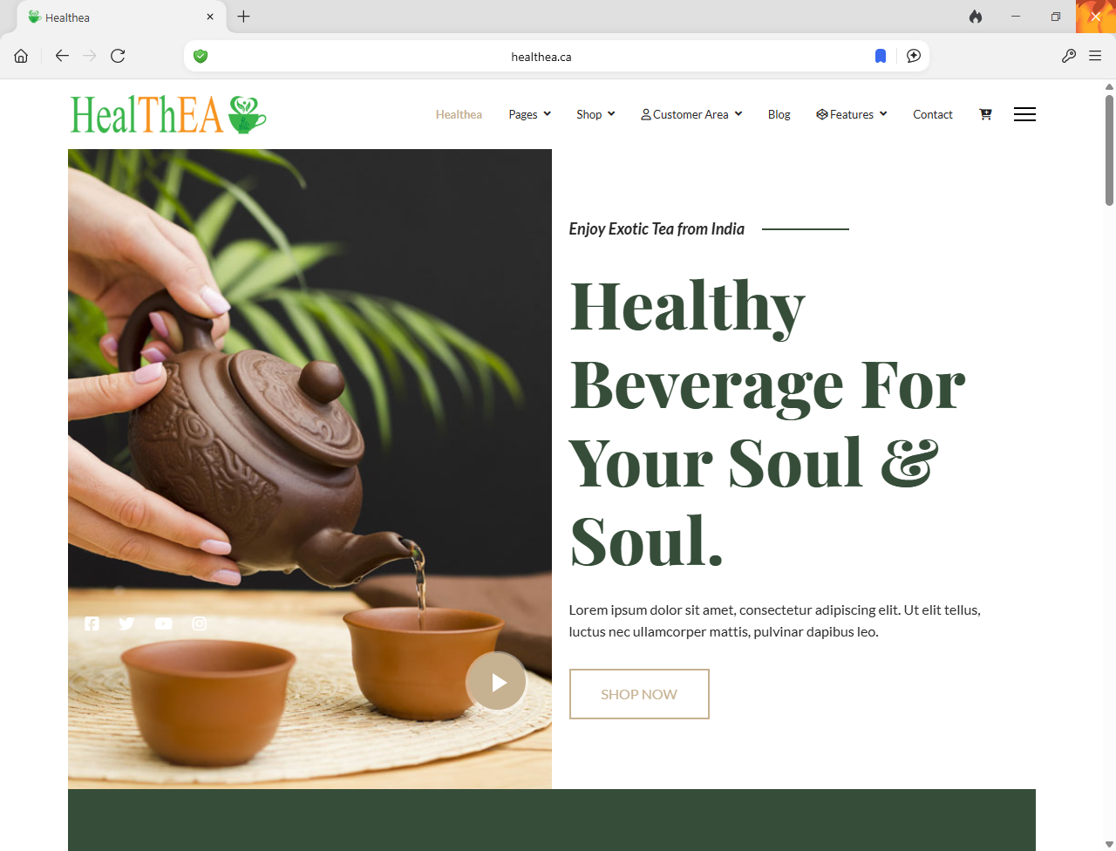

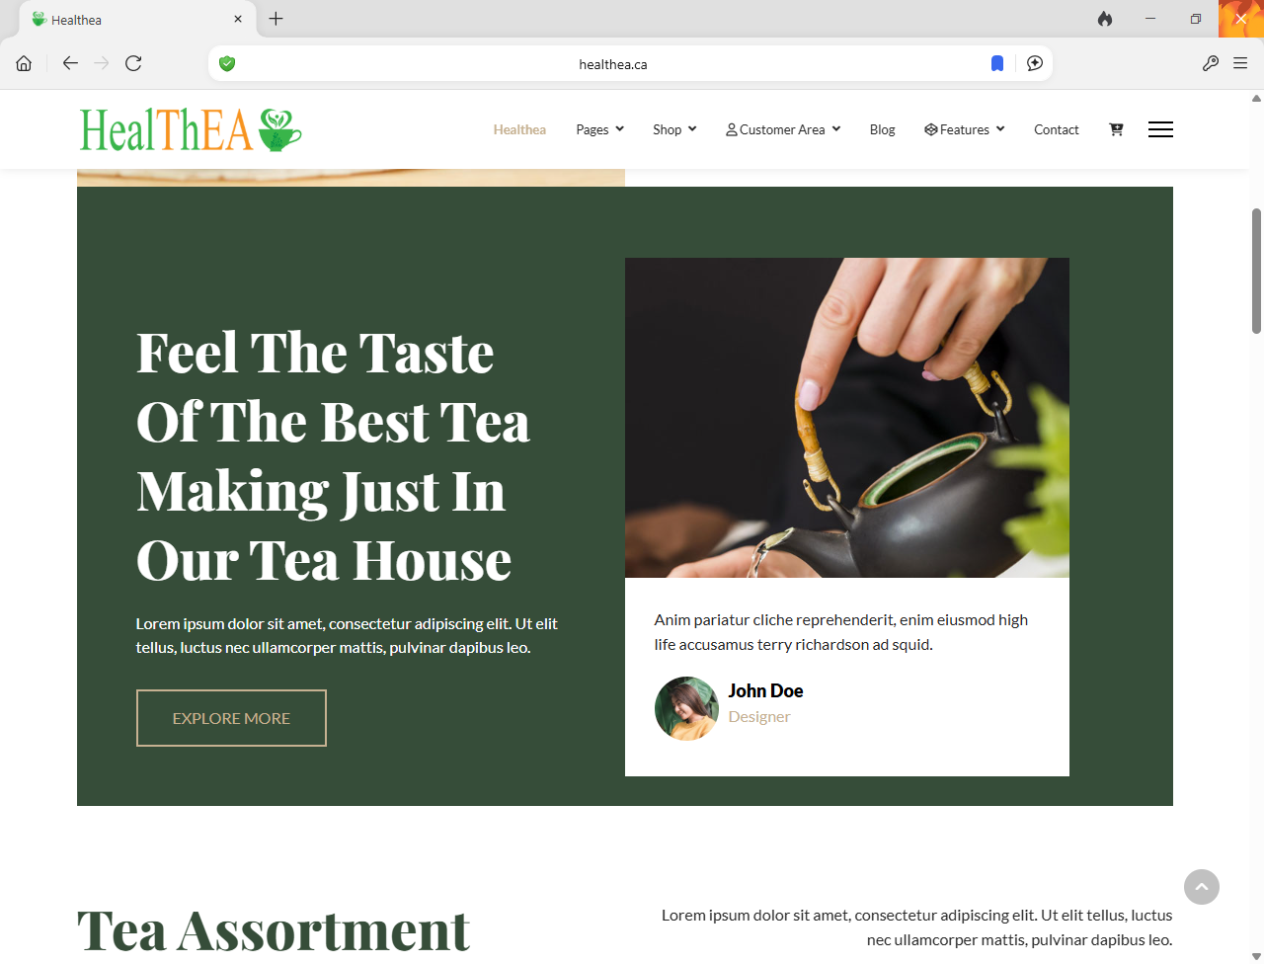

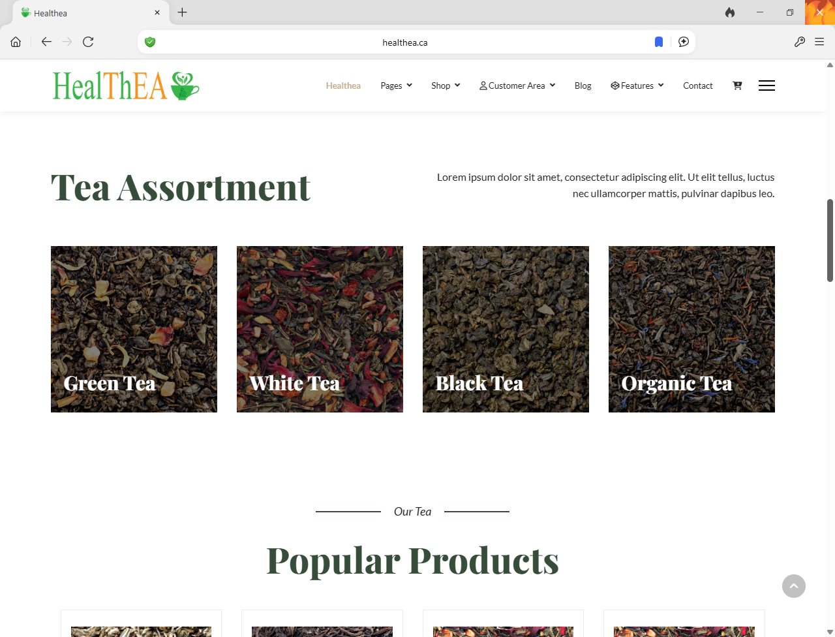

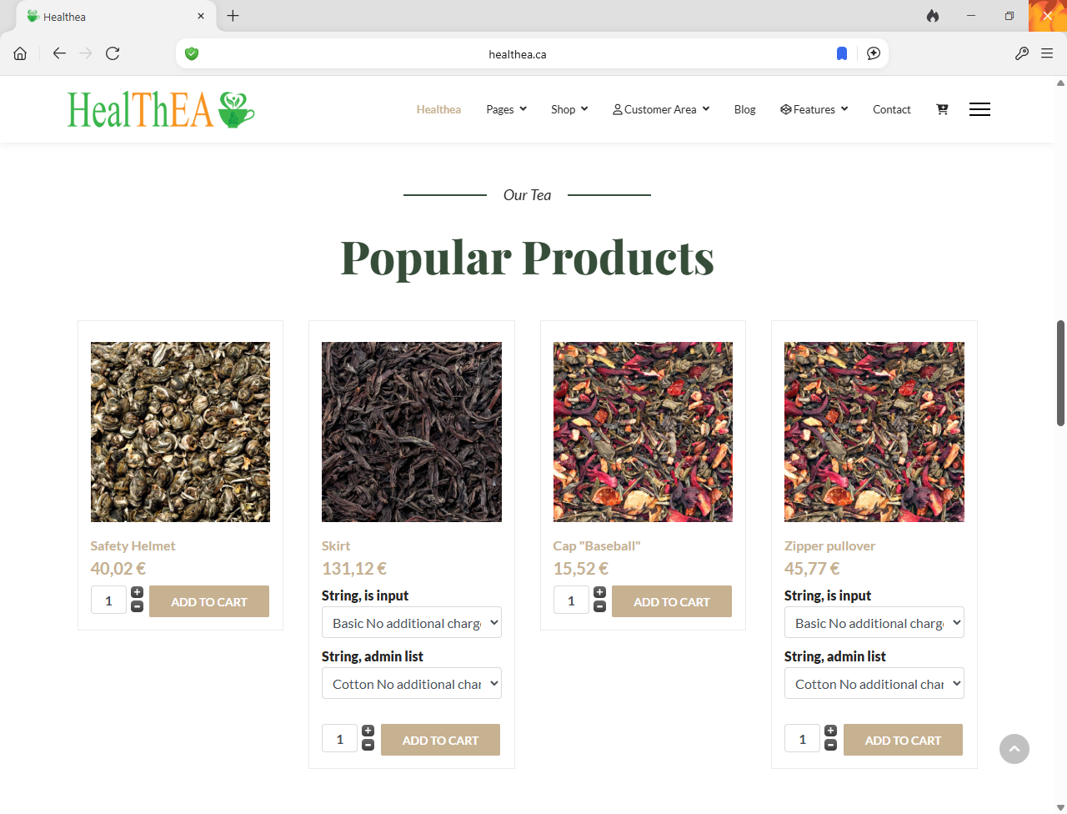

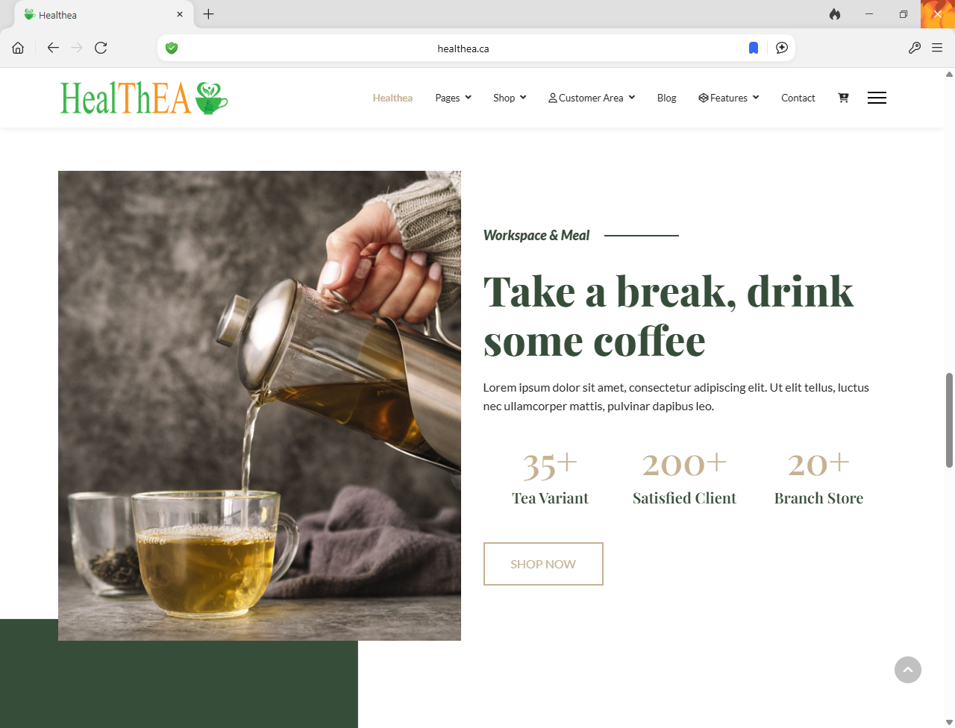

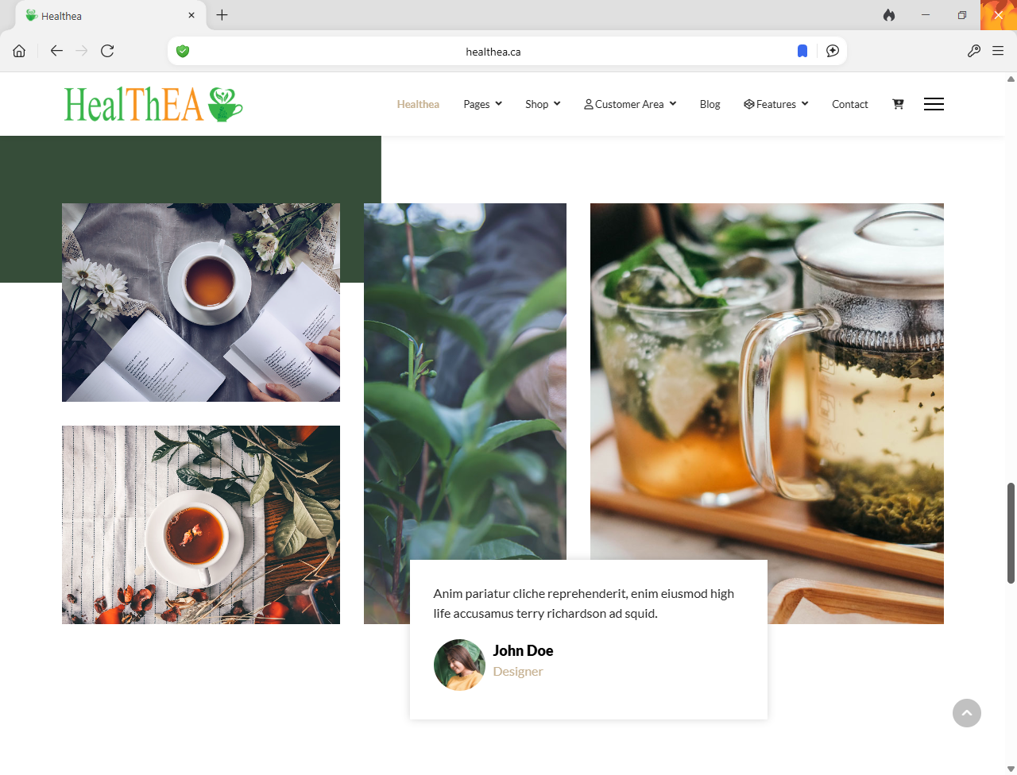

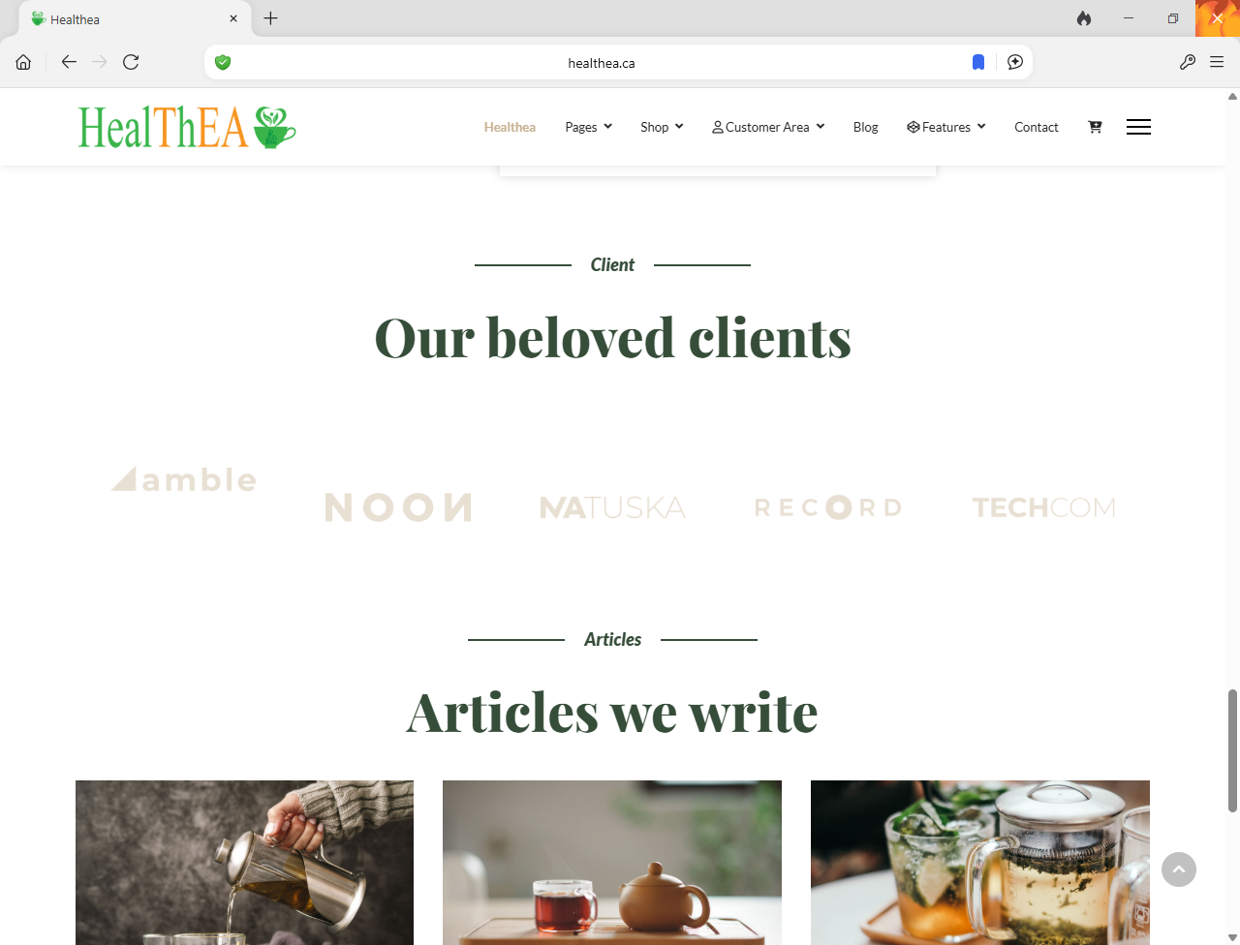

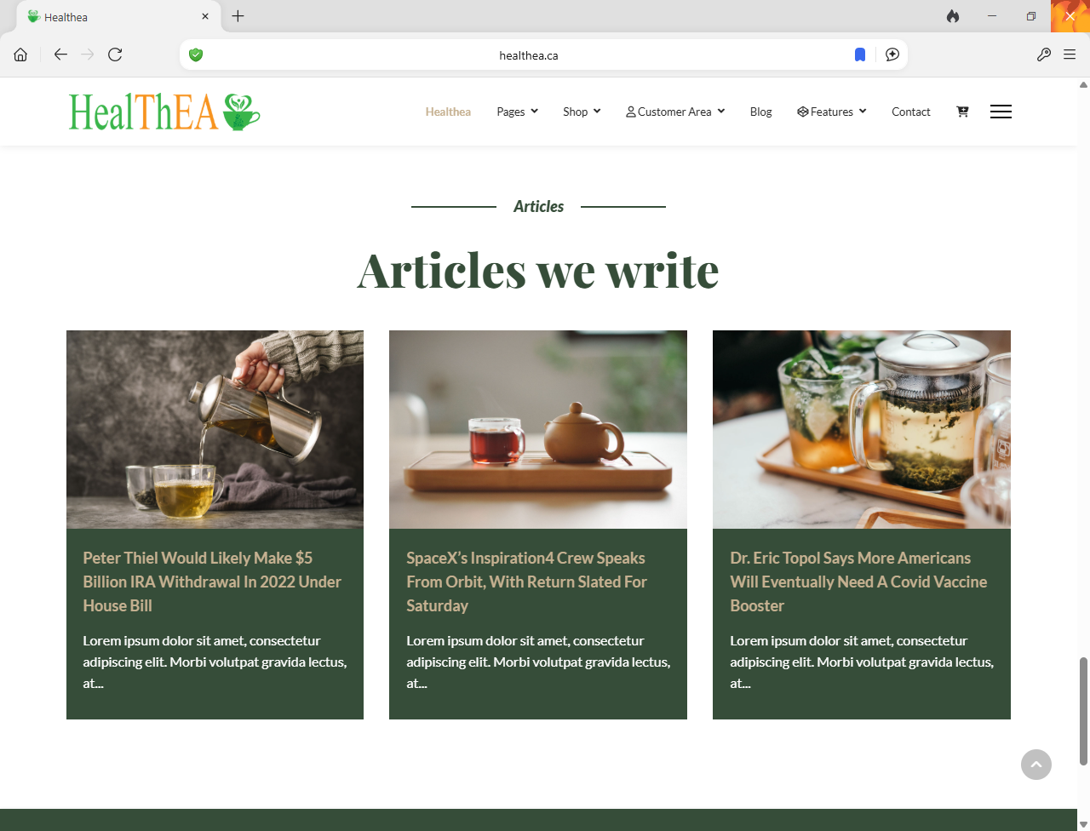

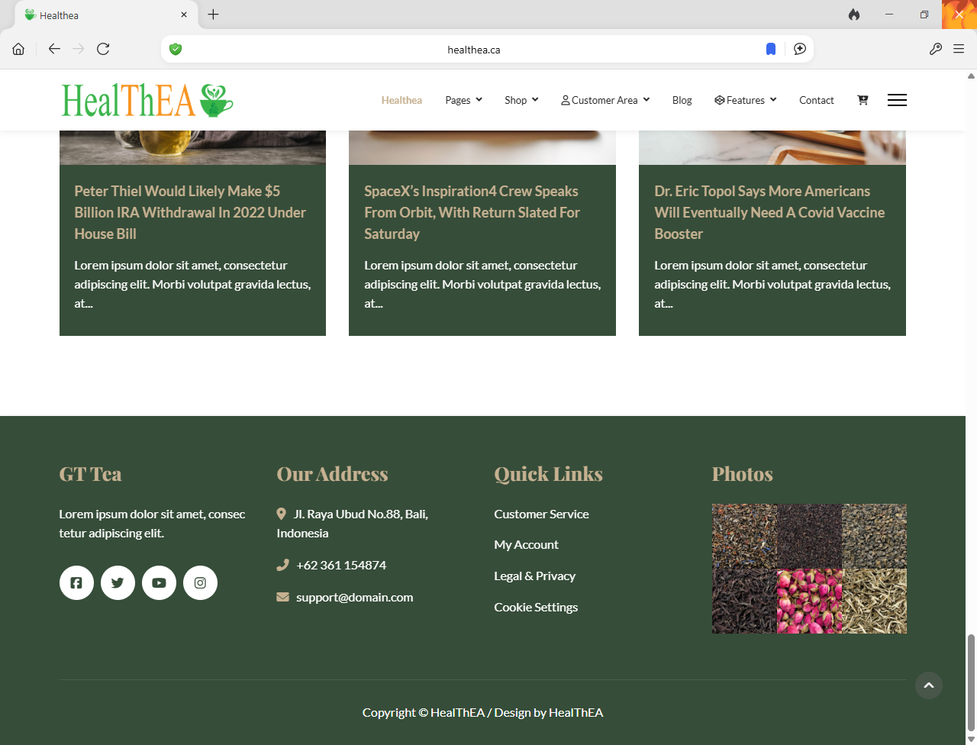

**Menus**

